|  |  |  |  |  |  |  |  |  |
| --- | --- | --- | --- | --- | --- | --- | --- | --- |
| Task Mode | Task Name | Duration | Start | Finish | Predecessors | Resource Names | Work | Cost |
| **Manually Scheduled** | LAN system | 42 days | أ 20/01/21 | خ 18/03/21 |  | Network engineer;Information security engineer 1;Developer1;trainer;Resourse Internal [1,000.00 ج.م.‏];Resourse External;Project manager | 1,902.32 hrs | 200,000.00 ج.م.‏ |
| Manually Scheduled | Purchase Servers | 7 days | أ 20/01/21 | خ 28/01/21 |  | Network engineer;Resourse External[30,000.00 ج.م.‏] | 82 hrs | 4,010.00 ج.م.‏ |
| Manually Scheduled | Purchase workstation and laptop computers | 7 days | ج 29/01/21 | إ 08/02/21 | 2 | Resourse External[50,000.00 ج.م.‏];Network engineer | 42 hrs | 11,000.00 ج.م.‏ |
| Manually Scheduled | purchase printers | 7 days | ج 29/01/21 | إ 08/02/21 | 2 | Resourse External[7,000.00 ج.م.‏] | 0 hrs | 2,555.00 ج.م.‏ |
| Manually Scheduled | Purchase windwos R2 server | 7 days | ث 09/02/21 | أ 17/02/21 | 3 | Developer1 | 56 hrs | 1,001.00 ج.م.‏ |
| Manually Scheduled | Purchase workstation operation system | 7 days | ث 09/02/21 | أ 17/02/21 | 3 | Project manager | 31 hrs | 1,552.00 ج.م.‏ |
| Manually Scheduled | Migrate of existing database and program | 14 days | ث 09/02/21 | ج 26/02/21 | 4 | Information security engineer 1;Developer1 | 149 hrs | 1,409.00 ج.م.‏ |
| Manually Scheduled | Training for client network administrator | 7 days | خ 18/02/21 | ج 26/02/21 | 5 | Developer1 | 50 hrs | 1,409.00 ج.م.‏ |
| Manually Scheduled | Introduction training for client personal | 7 days | خ 18/02/21 | ج 26/02/21 | 6 | trainer | 50 hrs | 1,409.00 ج.م.‏ |
| Manually Scheduled | Fully operational LAN system | 14 days | إ 01/03/21 | خ 18/03/21 | 7;8;9 | Network engineer;Developer1;Information security engineer 1 | 143.32 hrs | 2,555.00 ج.م.‏ |

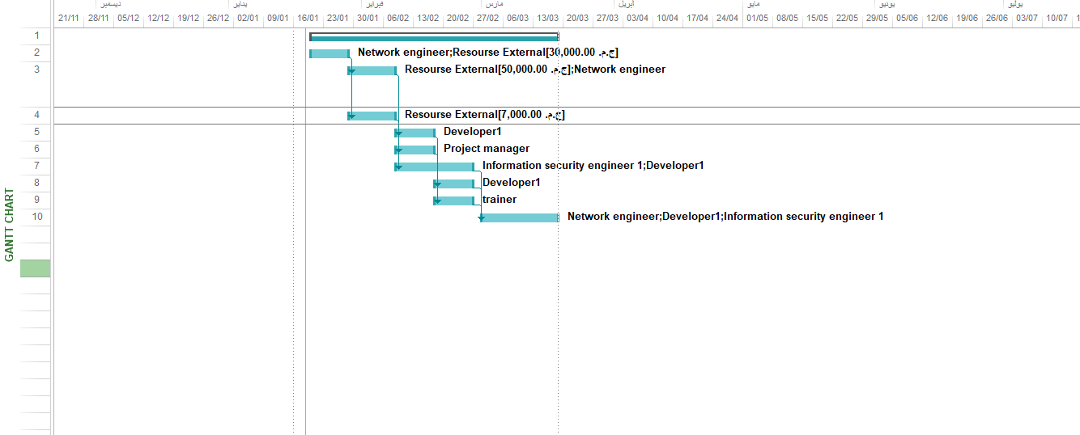

Resource sheet:

|  |  |  |  |  |  |  |  |  |  |  |
| --- | --- | --- | --- | --- | --- | --- | --- | --- | --- | --- |
| Resource Name | Type | Material Label | Initials | Group | Max. Units | Std. Rate | Ovt. Rate | Cost/Use | Accrue At | Base Calendar |
| **Network engineer** | **Work** |  | **N** |  | **100%** | **100.00 ج.م.‏/hr** | **50.00 ج.م.‏/hr** | **0.00 ج.م.‏** | **Prorated** | **Standard** |
| **Information security engineer 1** | **Work** |  | **I** |  | **100%** | **150.00 ج.م.‏/hr** | **100.00 ج.م.‏/hr** | **0.00 ج.م.‏** | **Prorated** | **Standard** |
| **Developer1** | **Work** |  | **D** |  | **100%** | **100.00 ج.م.‏/hr** | **50.00 ج.م.‏/hr** | **0.00 ج.م.‏** | **Prorated** | **Standard** |
| **trainer** | **Work** |  | **t** |  | **100%** | **150.00 ج.م.‏/hr** | **150.00 ج.م.‏/hr** | **0.00 ج.م.‏** | **Prorated** | **Standard** |
| Resourse Internal | Cost |  | R |  |  |  |  |  | Prorated |  |
| Resourse External | Cost |  | R |  |  |  |  |  | Prorated |  |
| **Project manager** | **Work** |  | **P** |  | **100%** | **150.00 ج.م.‏/hr** | **100.00 ج.م.‏/hr** | **0.00 ج.م.‏** | **Prorated** | **Standard** |

Resource usage:

|  |  |  |
| --- | --- | --- |
| Resource Name | Work | Cost |
| **Network engineer** | **395 hrs** | **39,500.00 ج.م.‏** |
| *LAN system* | *225 hrs* | *22,500.00 ج.م.‏* |
| *Purchase Servers* | *82 hrs* | *8,200.00 ج.م.‏* |
| *Purchase workstation and laptop computers* | *42 hrs* | *4,200.00 ج.م.‏* |
| *Fully operational LAN system* | *46 hrs* | *4,600.00 ج.م.‏* |
| **Information security engineer 1** | **410.83 hrs** | **61,624.22 ج.م.‏** |
| *LAN system* | *270 hrs* | *40,500.00 ج.م.‏* |
| *Migrate of existing database and program* | *76.83 hrs* | *11,524.22 ج.م.‏* |
| *Fully operational LAN system* | *64 hrs* | *9,600.00 ج.م.‏* |
| **Developer1** | **441.48 hrs** | **44,148.15 ج.م.‏** |
| *LAN system* | *230 hrs* | *23,000.00 ج.م.‏* |
| *Purchase windwos R2 server* | *56 hrs* | *5,600.00 ج.م.‏* |
| *Migrate of existing database and program* | *72.17 hrs* | *7,217.19 ج.م.‏* |
| *Training for client network administrator* | *50 hrs* | *5,000.00 ج.م.‏* |
| *Fully operational LAN system* | *33.32 hrs* | *3,330.96 ج.م.‏* |
| **trainer** | **350 hrs** | **52,500.00 ج.م.‏** |
| *LAN system* | *300 hrs* | *45,000.00 ج.م.‏* |
| *Introduction training for client personal* | *50 hrs* | *7,500.00 ج.م.‏* |
| Resourse Internal |  | 1,000.00 ج.م.‏ |
| *LAN system* |  | *1,000.00 ج.م.‏* |
| Resourse External |  | 87,000.00 ج.م.‏ |
| *LAN system* |  | *0.00 ج.م.‏* |
| *Purchase Servers* |  | *30,000.00 ج.م.‏* |
| *Purchase workstation and laptop computers* |  | *50,000.00 ج.م.‏* |
| *purchase printers* |  | *7,000.00 ج.م.‏* |
| **Project manager** | **305 hrs** | **45,750.00 ج.م.‏** |
| *LAN system* | *274 hrs* | *41,100.00 ج.م.‏* |
| *Purchase workstation operation system* | *31 hrs* | *4,650.00 ج.م.‏* |

Cash overview:

